User Handbook

Content

1. Preface
   1. Document Purpose
   2. Background Introduction
   3. Definition
   4. References
2. Software Introduction
   1. Software Functions
   2. Software Precision
   3. Security
3. Running Environment
   1. Hardware requirement
   2. Supporting software
   3. Data Structure
4. Use of Software
   1. Installation and Initialization
   2. Use Guide
5. **Preface**
   1. **Document Purpose**

This document is written for all the users who will use this face-recognition based student attendance recording system, including both admin and teachers.

This document will explain the hardware requirement, environment requirement, database requirement and working process of this system so that any departments or schools can easily implement and work with this system.

* 1. **Background Introduction**

1. **System name:**

Smart Class Attendance Taking System

1. **System required by:**

The university of Nottingham, Ningbo, China

1. **System developed by:**

GRP Group 17: Yiming Li, Boya Wang, Guohao Yu, Hongyi Zhu, Mingchen Li. Supervised by professor Zheng Lu.

1. **Target user**

For all UNNC teachers to use this system to take record of student’s attendance. To avoid using attendance sheet and waste session time and recoding time.

* 1. **Definition**
  2. **References**

1. **Software Introduction**
   1. **Software Functions**
2. User log in
3. View teacher’s profile
4. View all the module of this teacher account
5. View all the teaching session of selected module
6. View upcoming event
7. Start/continue/end attendance recording
8. View immediate attendance rate for a class
9. Search information based on student name
10. Detailed student information display
11. View searched information
12. View attendance sheet of a student
13. View attendance sheet of a teaching session
14. Sort teaching session list
15. Sort student attendance list
16. Sort session attendance list
17. Save session attendance information to local file
    1. **Software Precision**
18. **Search student information based on student name**

Input do not need to be the same as the student name. All the student names containing the input string will be returned. Letter case will not affect the result.

1. **face recognition precision**

Used open source OpenCV library to invoke API for face detection and face recognition. The face detection rate is extremely high that it can locate a face easily. The face detection rate is with a low accurate rate if only a few data is stored in the database. It can easily recognize an unknown face as a face stored in the database.

* 1. **Security**

1. **Running Environment**
   1. **Hardware requirement**
2. **model of processor and memory capacity**

2.3 GHz Intel Core i5， 8 GB

1. **on-line/off-line**

Off-line: Do not need internet connection

1. **database usage**

Local database using MySQL

1. **camera requirement**

Require pc with a camera or connected to a camera with USB 2.0

1. **disk capacity**

Allow this software to save files to the local file system and has enough space for these files

* 1. **Supporting software**

1. **Operating system**

MacOS with version 10.14.3

Window 10

1. **Programming language**

Python 3.7 or Python 2.7

1. **Database**

MySQL working with MySQL workbrench (version 8.0.15)

1. **OpenCV**

opencv-python-headless (version 3.4.2.16)

opencv-contrib-python-headless (version 3.4.2.16)

1. **Face recognition library in python**
2. **Numpy library in python**
3. **Datetime library in python**
   1. **Data Structure**
4. Attendance table

1. Student table

1. Teacher table

1. Module table

1. Lesson table

1. Login table

1. **Use of Software** 
   1. **Installation and Initialization**

Zip file is provided or users can download the whole program from <https://github.com/Yiming-Li666/GRP-P19.git> (Available at 2020-04-22)

After setting up all the running environment and database structure listed, users can directly run the main.py to use this program.

* 1. **Use Guide**

1. **After running the program, the login page will show up手机屏幕截图

   描述已自动生成**
2. **Login with invalid account and password will be denied**

1. **Forget password**

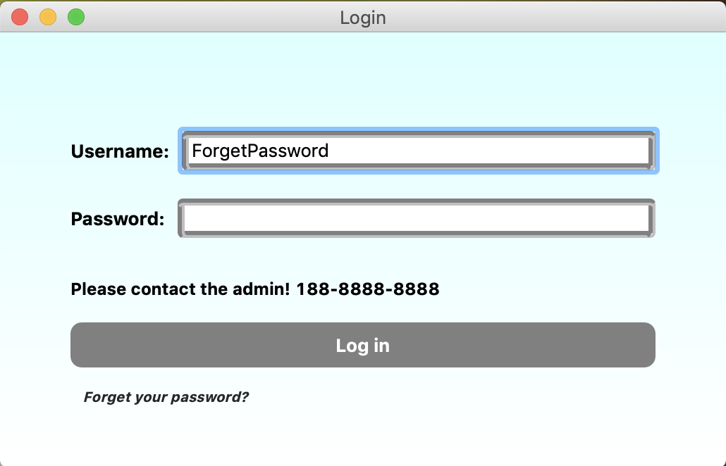

1. **Log in as an admin, the admin operation page will show up**

1. **Log in as a teacher, the module page will show up. Containing all the module Ids that the teacher teaches.**

1. **Click the target module to enter a session page. Taken “COMP1010”in this example. Containing all the session information of selected modules.**

1. **ComboBox can be used to sort all the sessions by time. Taken “Future” in this example.**

1. **Click the target session to enter next page. If the session has been recorded, a recorded page will show up. Taken “COMP1010 lecture6”in this example. Containing session information and absent information of selected sessions.**

1. **Click the target session to enter next page. If the session has not been recorded, a recording dialog will show up. Taken “COMP1010 lab6”in this example. Containing session Id and module Id of selected sessions.**

1. **Click “Start Record” button to go to the recording page.**

1. **Click “Start” button to open the camera and start recording**

1. **After being recognized, students need to click “Success” or “Fail” Button to confirm their information.**
2. **After clicking “Stop” button or all the students have been recorded, the recorded page will show up, which is the same view in 8) .**
3. **The search bar on the top of the window can search student names. Taken “li” in this example. A student list will show up.**

1. **Click the target student to enter a student detailed information page. Taken “Li Yiming” in this example. Containing all the detail information of selected students.**

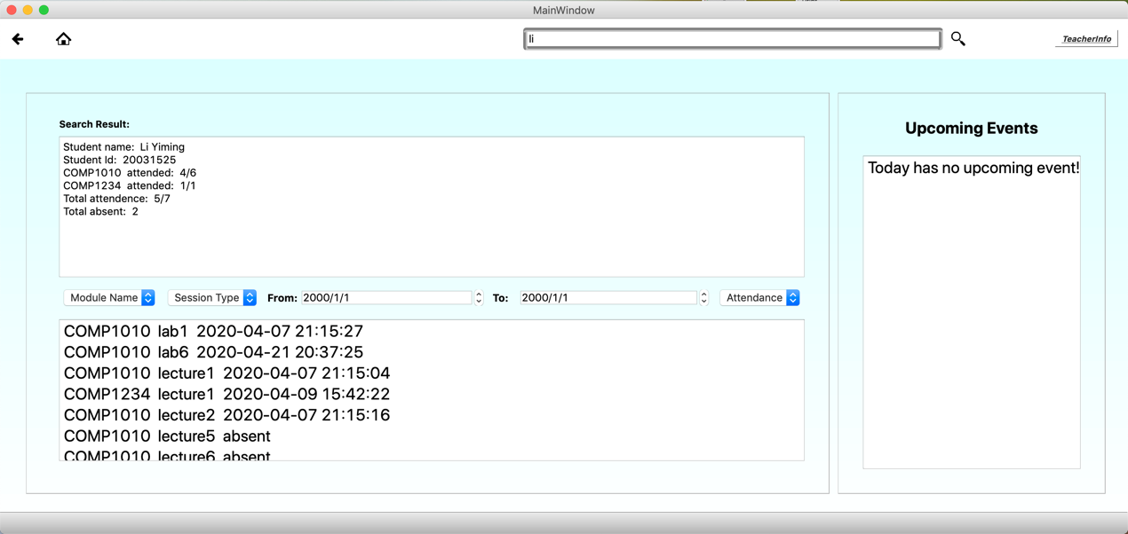

1. **ComboBoxes can be used to sort the session attendance information by module name, session type and attendance status. Taken “COMP1010”, “Lab”, “Attended” in this example.**

1. **Teacher can easily get all the absent session for that student by selecting “Absent” in attendance status.**

1. **The “TeacherInfo” button on the top right of the window can show teacher’s profile in a dialog.**

1. **The “Print” operation can be selected in the heading bar.**



1. **When clicking on “Print”, a print dialog will show up**

1. **ComboBoxes can be used to sort the sessions by module Id and session type. Taken “COMP1010” and “Lab” in this example.**

1. **Choose the target session to do save operation. Take “COMP1010 Lab6” in this example.**

1. **Local file will be created, naming as “moduleId+sessionId.csv”.**

1. **The format of saved file will contain a headline with property names. Taken “COMP1010lab6.csv” in this example.**

